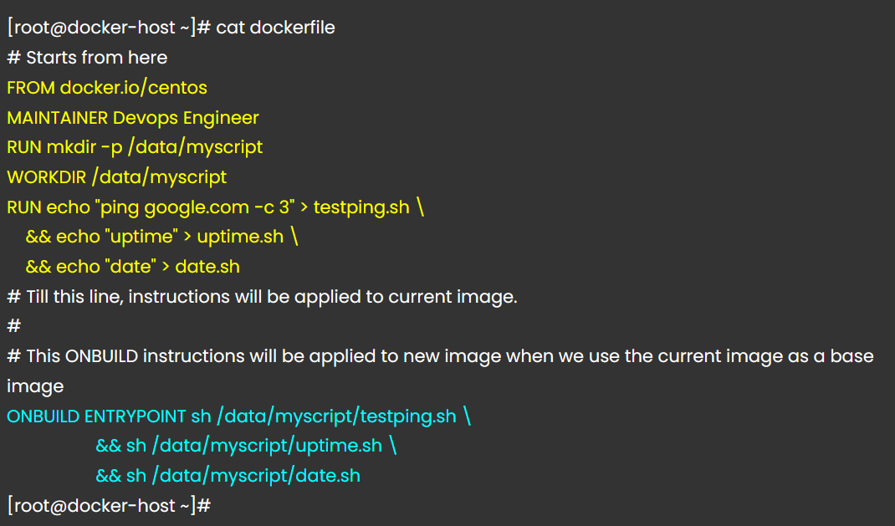

Sample code

* FROM ubuntu
* CMD echo "Hello world"
* ONBUILD CMD echo "Hi"

Base image: Hello world first time.

If we use this as parent, then it will execute Hi

